3rd Grade News | November/December 2019
What we’re Learning:  With quarter two comes all new units! In reading, students are beginning a module on Freaky Frogs. We start the module by reading poetry and pourquoi tales to help students learn the parts of a narrative, in preparation to write their own. Later, we will focus on nonfiction reading- we will focus our learning on text features and text connections.  In math, we are wrapping up our addition and subtraction unit. We will finish it out with multi-step problems where they must be able comprehend the problem first, and then decide the two equations that will help them arrive at an answer. From here we will revisit addition, this time with a heavier emphasis on division, and the relationship between the two.  In Social Studies we started our next topic, government. Students will dive into state and local government and then complete a community service activity that will teach them about civics.  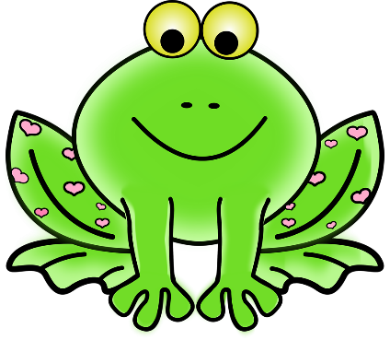  How can you help at home?  -Continue to give them practice with 3 digit addition and subtraction, even after we move on.  -Ask your child questions about nightly reading. | Literacy Night!  mARK YOUR CALENDAR. lITERACY nIGHT IS dECEMBER 3RD. sEE SCHEDULE BELOW:  5:30-7:30  BOOK fAIR OPEN IN MEDIA CENTER  5:30-6:45  gRADE LEVEL LITERACY ACTIVITIES  5:30-7:00  cAFETERIA OPEN FOR DINNER  7:00  SLY SOUND PEPRFORMANCE  Save the Date:  - 11/11- Veteran’s Day- no school  - 11/16- Campus Clean Up (10 AM-12 PM)  - 11/19- Spirit Night: BurgerIM  - 11/27-12/1- Thanksgiving Break  - 12/3—Literacy Night  - 12/2-12/6- Book Fair!  - 12/6- Field Trip- NC Museum of Natural Science  - 12/18- Spirit Night: Papa John’s  - 12/20- Inclement Weather Make-Up Day  - 12/23- Holiday Break Begins

